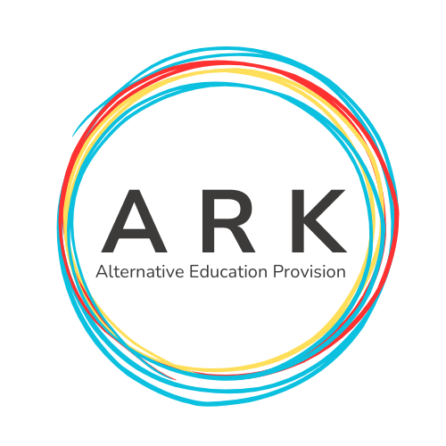 | 01ARK NEWSLETTER
WK1 | Welcome to our first ARK Newsletter! This week saw us getting super excited to welcome all our brilliant learners and families. We thought about who we are and our core values. The Team worked with pupils to create Pledges and Policies to keep us safe and ready to learn. | 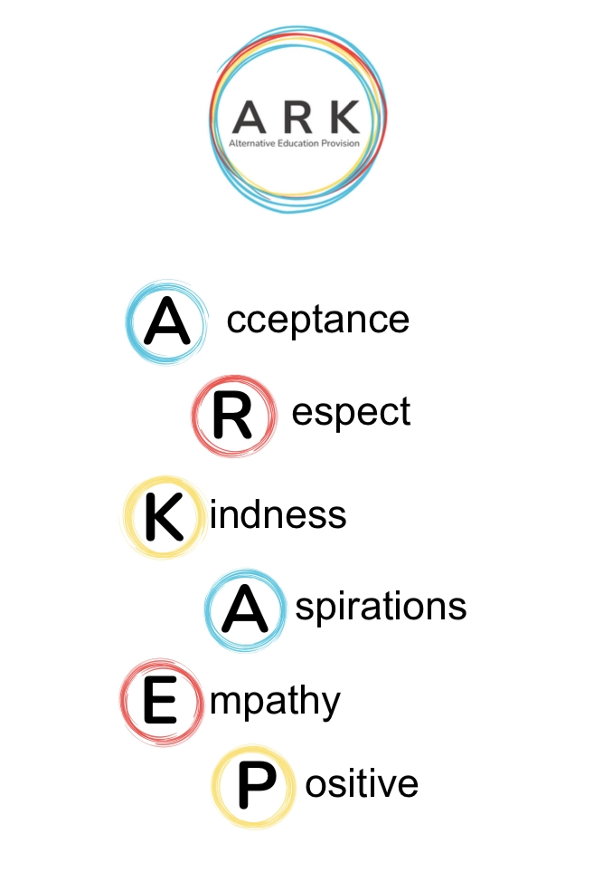
WK2 | Week 2 flew by! Meet our first ever pupil-Harvey! Harvey told us he really enjoyed his ARK learning and took to exploring the World during his Euro 2024 task! Harvey aimed to find all the flags that represent the tournament and actually found many more. It was great getting to know Harvey and even better to know he loves a debate as much as us. Which came first, the chicken or the egg? Leading us into our thoughts around evolution :) | 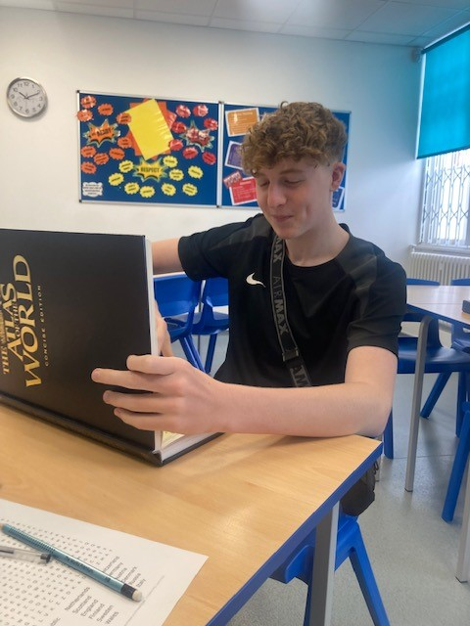
WK3 | This week our learners completed Baseline Assessments and took part in their Euro 24 Maths and English tasks. We welcomed Lily, Finn, Jake and Lucas to the team and enjoyed getting to know each other! Star of this week was Finn-for his mature approach to learning and behaviour. We hope Finn enjoys his free cinema tickets that he won 😊 All ARK Learners also joined the library and will be making use of the great facilities and encouraged to read to expand a love of language and reading. Let’s not forget our Remote Learners who are working hard from home. Mia completed some wonderful English work and Zak is also working super hard with his Maths and English work each week and attended his sessions with commitment. | 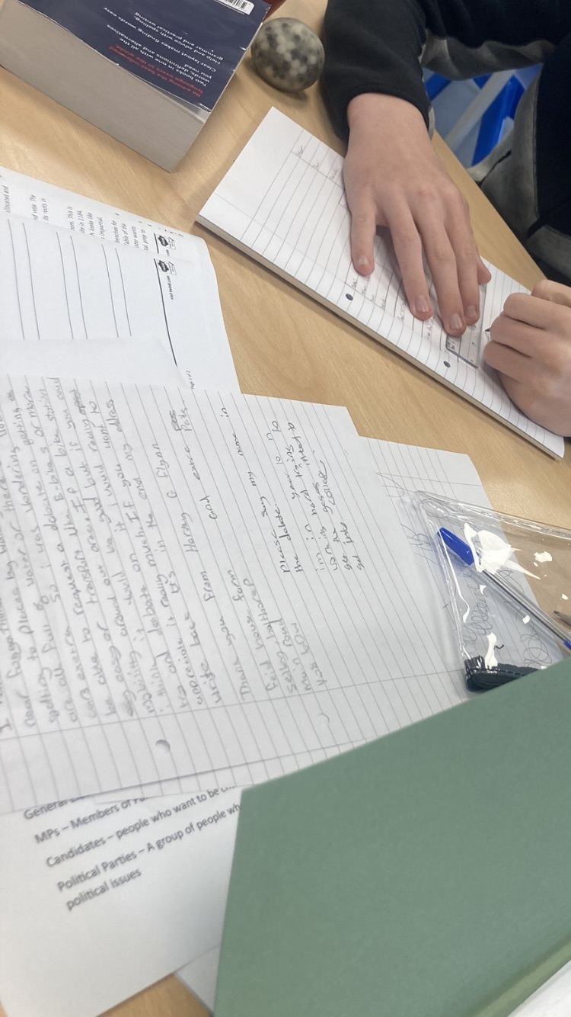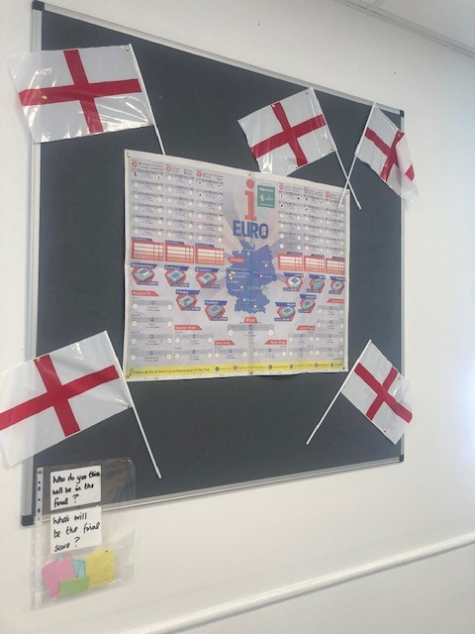
WK4 | The ARK Team really looks forward to our Lesson 3 Personal Development Learning. Lily can be seen here, measuring ingredients and following a cookie recipe. Cookies are always ready for our learners, visitors and families to taste test 😊  Extra Information-  Please look out for our next Newsletter and find them all on our website at www.arkaep.co.uk | 