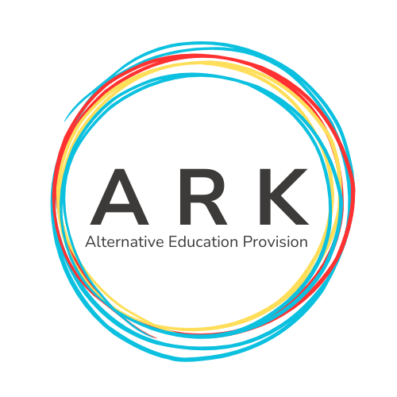
Equality & Inclusion
Policy

Title | Equality and Inclusion Policy
Summary | This policy sets out our commitment at ARK Alternative Education Provision and approach to equality, diversity and inclusion.
Purpose | To ensure that all stakeholders are aware of this policy and its application in relation to equality, diversity and inclusion for all pupils and staff.
Operational Date | 17.04.2024
Frequency of Review | Every Year

- Introduction
ARK Alternative Education Provision is committed to equality and inclusion.
We recognise the value of diverse environments and strive to promote a culture in which all pupils, staff and members of the school community are welcomed and supported to fulfil their potential, irrespective of their background or personal characteristics.
We are committed to an ethos and culture of inclusion in our School for all pupils, irrespective of race, religion/belief, political views, disability, SEN status, gender, gender identity (e.g. transgender) and/or sexual orientation (LGBTQ+).
ARK Alternative Education Provision is an inclusive school where we focus on the well-being and progress of all our children and young people and where all members of our school community are of equal worth.
We recognise, respect and value difference and understand that diversity is a strength that enriches our lives. We take account of differences and strive to remove any barriers to learning and development.

We oppose all forms of unlawful and unfair discrimination and bullying and harassment. As a school community, we recognise the need to champion equality and ensure inclusion for all pupils in the full life of our school; where appropriate making necessary adjustments to enable everyone’s participation.

Name of School believes that education (both formal and informal learning) is fundamental to equality of opportunity. It prepares young people for life and is a powerful influence on access to and advancement in employment. All young people should be able to learn and develop fully in a truly diverse and inclusive environment.
All our policies and practices are fully inclusive and supportive of a welcoming culture for all communities; this is evidenced in our practices and procedures.

- Mission and Values
ARK Alternative Education Provision will embrace and welcome all our young people, families, visitors and colleagues. We strive to create a safe and happy learning environment. Our core values centre around a positive and safe culture, which underpins all we do. We are unique and we are includers, we encourage and model acceptance and kindness in all we do and all we want to be.

- Equality and Inclusion – School Policies
Through this policy, and the wider practices within ARK Alternative Education Provision we seek to empower our young people to embrace diversity and challenge discrimination. We equip our Governors and staff to fulfil their legal responsibilities, ensure that our school’s safeguarding procedures are comprehensive and inclusive and enable robust monitoring of our progress as a school.

Inclusion underpins all our school policies.

As part of our overall school policy development there are a number of policies that we must have in place and regularly review to ensure our school is addressing its statutory responsibilities. These include Anti-bullying Policy, Safeguarding Policy, Curriculum Policy, Positive Behaviour Policy, Uniform Policy and Admissions Policy. Any arising incident will be dealt with by the appropriate policy. There should never be any grey areas when it comes to young people’s safety and well-being.

This is supplemented by a range of other policies that as a school we feel are important to have for our whole school community. It is our belief that equality and inclusion is central to all of our policies and that we maintain an ethos that welcomes diversity and promotes equal opportunities for all, ensuring all our pupils and their families feel valued and supported and making sure that equality and inclusion is evident in everyday school life.

- Responsibilities
The Directors along with Commissioning Schools have an overall responsibility to:

‘Promote equality, good relations and diversity and to comply with education and employment legislation and anti-discrimination, human rights and equality legislation that affect its statutory duties in relation to the school’ ‘Every school a good school – the governors role’ (Department of Education, August 2019)
The Governors have overall responsibility to manage the implementation of equality and diversity in our school.
We are responsible for:
ensuring policies and procedures are in place to comply with equality legislation;
- ensuring the school implements policies and practices in line with the principles of equality and inclusion;
- following the relevant procedures and taking action in cases of unfair discrimination, harassment or bullying;
- ensuring appropriate training and awareness raising is undertaken with staff;
- ensuring that appropriate records are kept of any cases of unfair discrimination, harassment or bullying.

The School Senior Management Team are responsible for:
- putting the school’s equality and inclusion policies and codes into practice;
- making sure that all staff know their responsibilities and receive the support and training necessary to carry them out;
- following the relevant procedures and taking action where necessary.

The School’s Pastoral Care and Safeguarding Team (led by the Designated Teacher) will manage the implementation of the policy in partnership with the Directors.

All School Staff (teaching and non-teaching) have a responsibility for the day to day operation of this policy and will contribute to an inclusive and welcoming environment within the school.

Pupils/students are responsible for:
- respecting others in their language and actions;
- following all of the relevant school policies and codes of conduct in line with the principles of equality and inclusion.

- How do we promote Equality and Inclusion?

ARK Alternative Education Provision promotes equality and inclusion within our school through the following activities:

- School/Centre Practices – meaningful interactions and reviews
- Policies
- Facilities
- Curriculum
- Training

- Monitoring the Success of the Equality and Inclusion Policy
The policy will be monitored by monitoring Pupil and Parent Voice and consistently education those who use the Provision to ensure relevant awareness is implemented in all we do and the culture of ARK Alternative Education Provision.

- Complaint’s Procedures
The school has a robust and transparent Complaints procedure. If a complaint is made regarding equality or inclusion, the Complaints process will be fairly and systematically applied. Access to the Complaints procedure can be found on the schools website (currently undergoing construction) or via the Director’s emails on
allison.middlemas@arkaep.co.uk
kay.walton@arkaep.co.uk

- Review cycle of policy
The Equality and Inclusion Policy will be reviewed by all stakeholders (detail how) and, if required, updated every three years in line with our school policy review cycle.

